The Local Epicurean

12 Bottle Wine Cellar
- Belle Glos Oeil De Perdrix, Sonoma County, 2022
- Scheid Vineyards Pinot Noir Estate Grown Monterey, 2018
- Champagne Fleury, Blanc De Noirs
- Metz Road, Pinot Noir Riverview Vineyard Estate Grown Monterey, 2019
- Cotiere, Sandford & Benedict Vineyard Blanc De Noir, 2019
- Edict Napa Valley Proprietary Red, 2020
- Ridge Carignane, Buchignani, 2021
- Ridge Corralitos Pinot Noir, 2020
- Ridge Zinfandel, Buchignani, 2018
- Ridge Estate Chardonnay, 2020
- Folktale The Lion For Real Orange Wine, 2020
- Surprise Bottle!

Grasings
- Farmer’s Market Menu for Two
- Valid Sunday thru Thursday, blackout dates apply
- May not be applied toward gratuity or alcohol purchases
- Certificate has no cash value and is non-transferrable
- Expires 10/1/24

Social Hour
- Yes Cocktail Co. Meyer Lemon Mixer
- Rock Flower Paper Whale Art Coaster Set (4)
- A Bar Above Classic Mixing Glass
- A Bar Above Smooth & Spiral Bar Spoons, Stainless Steel
- Social Hour Bar Apron
- Bitter Ginger 2oz. Orange Bitters

Patisserie Boissiere
- Gift certificate good for 4 pastry selections (up to $30 value)

Elroy’s Fine Foods
- Gift Card for $50

Before the Rain
- 12x16'' Watercolor
- Framed, ready to hang
- By artist, Theodore Heublein
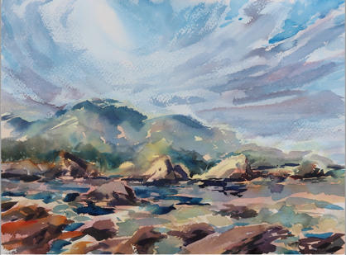

The Sustainable Adventurer

Whisper Charter
- Eco-electric Boat Tour
- Book through website, use reference code
- Based on availability
- Valid for up to 6 people
- 2 hour tour of Elkhorn Slough

Ami Carmel
- SunnyLife Round Picnic Cooler Basket
- Wooden lid doubles as a cheese board
- Classic wicker basket, capacity 9.25 gallons, removable rosewood lid, insulated interior with zip closure, wooden handles, food and dishwasher safe, 14.96 x 14.96 x 12.6 in
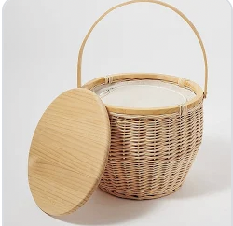

Eco Carmel
- Set of two cloth napkins
- Bamboo to-go cutlery
- Two wine glasses
- Hand Sanitizer
- Gift Certificate

Nut Hut
- 3 packages include one chocolate mix, one fruit mix, one Bixby mix
- Gift certificate

Adventures by the Sea
- Kayak Tour for two people (10 am or 2 pm open tour)
- Children must be 5 years old to kayak in a tandem with parents and 14 years old to kayak in a single
- No expiration date
- Reservations recommended
- Present gift certificate to redeem

Monterey Zoo
- Family Day Pass (2 adults & 2 children [2-14yrs])
- Visit montereyzoo.org for more information or call 831-455-1901

Monterey Bay Retreat

Portola Hotel & Spa
- Complimentary One Night Stay in a Portola Room, based on availability
- Complimentary Breakfast for two at Jacks Monterey
- Present certificate when making reservation

Monterey Touring Vehicles
- Choose from fleet of classic cars
- Based upon availability
- Must use promo code
- Not valid on holidays or during Monterey Car Week
- Contact Monterey Touring Vehicles prior to booking
- Expires 9/18/24
- Swag bag included

Folktale Winery & Vineyards
- 2 Complimentary Folktale Tasting Flights
- Tasting reservations Recommended (831) 293-7500
- 2016 Folktale Reserve Chardonnay (1.5 L)

Cashmere Scarf
- Fiorla, 100% cashmere scarf, OS, Wine Red

La Mia Cucina
- Certificate for $100 at La Mia Cucina for food and non-alcoholic beverages
- Wednesday thru Sunday
- No cash value
- Expires 7/1/24

2015 Campaperi, Brunello Di Montalcino

Revival Ice Cream
- Gift Card, value of $25

Pacific Grove California Monarch Butterfly Mosaic 1000 pc Puzzle

A Carmel Getaway

Cypress Inn
- One night stay in a deluxe room
- Sunday-Thursday, reservations required and subject to availability at time of booking
- Black-out dates may apply during holidays or special events
- Breakfast included, alcohol and gratuity not included
- Present original certificate upon arrival. Lost certificates cannot be replaced.
- Expires 7/31/24
A Carmel Getaway (cont’d)

Yoga with Kimberly Wolff @ Gallery MAR
- Schedule at mutually agreed date and time
- Not available during gallery hours

Manzoni Cellars
- 2 Deluxe Wine Tastings
- VIP room access
- Charcuterie included
- Expires 9/17/24
- Call for Reservation: 831-620-6541
- Present Certificate

The Hidden Gem
- Gift Certificate, Lunch for 2, $150.00
- Present Gift Certificate

